# Class Room Robot – User Manual

This application was made to help teachers keep track of their students’ attendance and seating locations for each class. You are also able to enter information about the locations of the students, their name and alter the layout of the room. A file can be saved for each day class is taken and previous classes can be opened and altered.

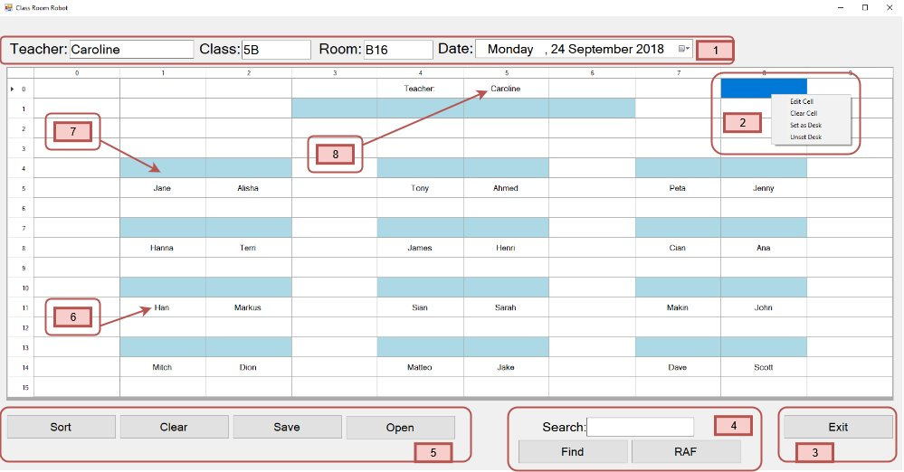

(Image 1.0 – User Interface)

There is only one user interface available which can be broken up into 5 sections:

* Image 1.0 – Section 1: This section shows all relevant information related to the currently selected class. All fields can be altered so they reflect the correct class details which is saved with the data in the class layout. The fields in this section are:
  1. Teacher’s Name
  2. Class ID
  3. Room ID
  4. Date Selector (Date Picker) – The day of which the class was sat
* Image 1.0 – Section 2: These are the selections for the right click context menu:
  1. Edit Cell – Changes change the state of the currently selected cell, so it can be edited.
  2. Clear Cell – Clears all text from the currently selected cell.
  3. Set as Desk – Changes the colour of the currently selected cell to indicate that it is a desk.
  4. Unset Desk – Changes the currently selected cell back to white which indicates that it is no longer a desk.
* Image 1.0 – Section 3: This button closes the main window

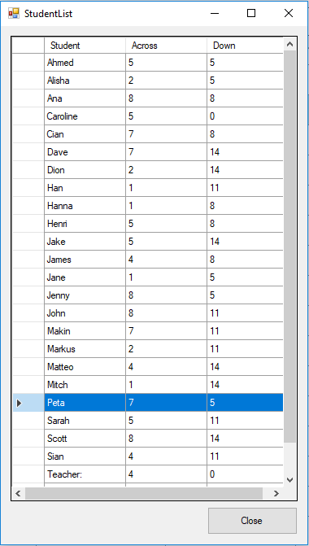

(Image 2.0 – Student List Window)

* Image 1.0 – Section 4: This section handles the search functions for the window.
  1. Search Text Box – Enter the search details into this box before selecting a button.
  2. Find – This function will only work if the full name of the student is typed into the search box before the button is selected. After the search function is complete, the result will be highlighted in the main window (Image 1.0) and the Student List Window will open (Image 2.0). All students will be listed in alphabetical order and the result will be highlighted here also.
  3. RAF of Random Access File – This button uses a random access file function to index each student entry in a file to speed up the search process. This will only work if the record number of the data is typed into the search box before the button is selected. After the search function is complete, the result will be highlighted in the main window (image 1.0) and the Student List Window will open (image 2.0). All students will be listed in alphabetical order and the result will be highlighted here also.
* Image 1.0 – Section 5: This section contains buttons that perform useful functions.
  1. Sort – This button will open the Student List Window (image 2.0) to display all the students name and grid locations in alphabetical order
  2. Clear – This button clears all student names from main window. **Warning! If the data is cleared and the changes are saved, the data cannot be retrieved.**
  3. Save – This button saves all the changes in the current window to its own file with a date stamp to know when that file was generated.
  4. Open – This button opens a dialog window (Image 3.0) where other class files can be accessed by selecting the file and clicking the open button in the bottom right of screen.

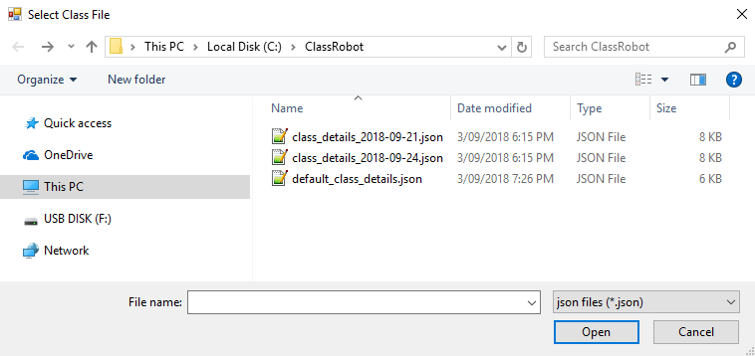

(Image 3.0 – Dialog Window)

* Image 1.0 – Section 6: This is showing a cell in the data grid view that contains a student name. This data can be altered using the right click context menu or double clicking on the desired cell.
* Image 1.0 – Section 7: This is showing a cell that is coloured light blue indicating that this represents a desk. Desks can be added and removed by using the options in the right click context menu.
* Image 1.0 – Section 8: This is showing the cell that contains the teachers name. This can be altered in the data grid view or by changing the text box in section 1.